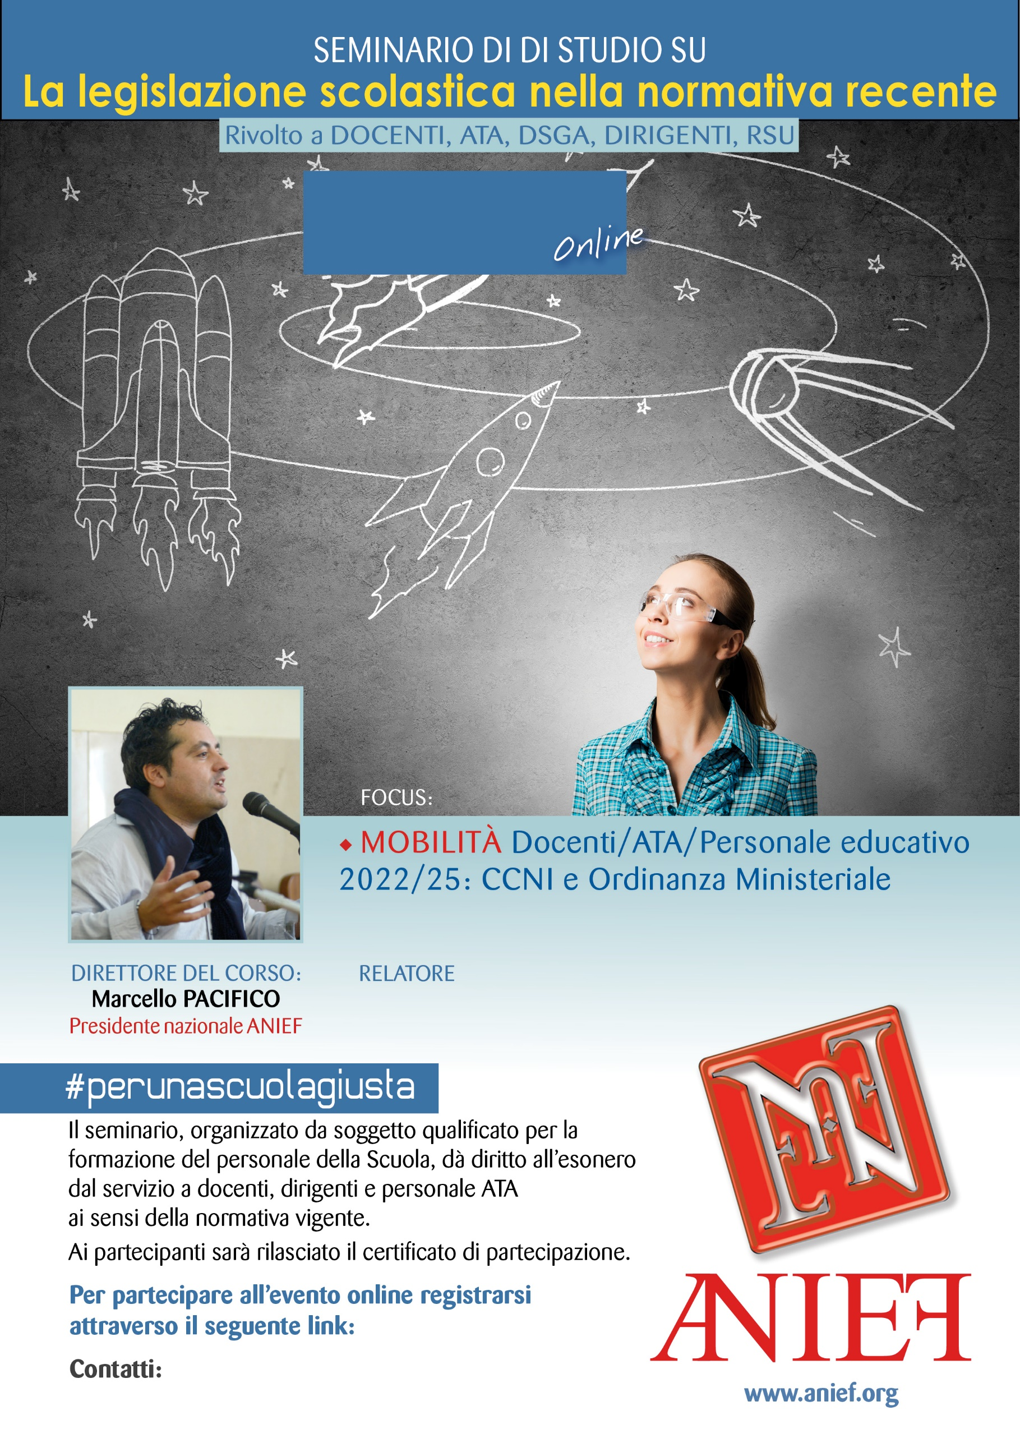
LINK DIRETTA: https://anief.org/as/3U2H
napoli1@anief.net
STEFANO CAVALLINI
CAMPANIA - NAPOLI
10/03/2022 ORE 09:00 – 11:00

