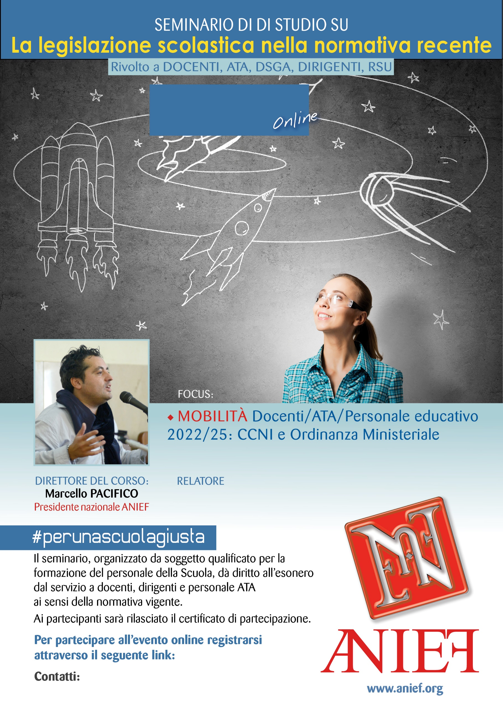
LINK DIRETTA: https://anief.org/as/DB31
salerno@anief.net - benevento@anief.net
ALESSANDRO SOLA
CAMPANIA SALERNO/BENEVENTO
11/03/2022 ORE 09:00 – 11:00

